Batch: C3 Roll No.: 16010123217

Experiment No. 10

Grade: AA / AB / BB / BC / CC / CD /DD

Signature of the Staff In-charge with date

Title: Study, Implementation, and Analysis of the Longest Common Subsequence Algorithm.

Objective: To compute longest common subsequence for the given two strings.
CO to be achieved:
CO 2 | Analyze and solve problems for divide and conquer strategy, greedy method, dynamic programming approach and backtracking and branch & bound policies.
CO 3 | Analyze and solve problems for different string matching algorithms.

Books/ Journals/ Websites referred:
- Ellis horowitz, Sarataj Sahni, S.Rajsekaran,” Fundamentals of computer algorithm”, University Press
- T.H.Cormen ,C.E.Leiserson,R.L.Rivest and C.Stein,” Introduction to algortihtms”,2nd Edition ,MIT press/McGraw Hill,2001
- http://www.math.utah.edu/~alfeld/queens/queens.

Pre Lab/ Prior Concepts:
Data structures, Concepts of algorithm analysis

Historical Profile:
Given 2 sequences, X = x1 , ..., xm and Y = y1 , ... , yn , find a subsequence common to both whose length is longest. A subsequence doesn’t have to be consecutive, but it has to be in order.
New Concepts to be learned:
String matching algorithm, Dynamic programming approach for LCS, Applications of LCS.

Recursive Formulation:
Define c[i, j ] = length of LCS of Xi and Y j .
Final answer will be computed with c[m, n].

c[i, j]= 0
if i=0 or j=0.
c[i, j]= c[i − 1, j − 1] + 1
if i,j>0 and xi=yj

c[i, j]= max(c[i − 1, j ], c[i, j − 1])
if i, j > 0 and x_{i} <> y_{j}

Algorithm: Longest Common Subsequence

Compute length of optimal solution-
LCS-LENGTH ( X , Y, m, n)
for i ← 1 to m
do c[i, 0] ← 0
for j ← 0 to n
do c[0, j ] ← 0
for i ← 1 to m
do for j ← 1 to n
do if xi = y j
then c[i, j ] ← c[i − 1, j − 1] + 1
b[i, j ] ← “≈”
else if c[i − 1, j ] ≥ c[i, j − 1]
then c[i, j ] ← c[i − 1, j ]
b[i, j ] ← “↑”
else c[i, j ] ← c[i, j − 1]
b[i, j ] ← “←”
return c and b

Print the solution-
PRINT-LCS(b, X , i, j )
if i = 0 or j = 0
then return
if b[i, j ] = “≈”
then PRINT-LCS(b, X , i − 1, j − 1)
print xi
elseif b[i, j ] = “↑”
then PRINT-LCS(b, X , i − 1, j )
else PRINT-LCS(b, X , i, j − 1)

Initial call is PRINT-LCS(b, X , m, n).
b[i, j ] points to table entry whose subproblem we used in solving LCS of Xi
and Y j.
When b[i, j ] = ≈, we have extended LCS by one character. So longest com- mon subsequence = entries with ≈ in them.

Example: LCS computation
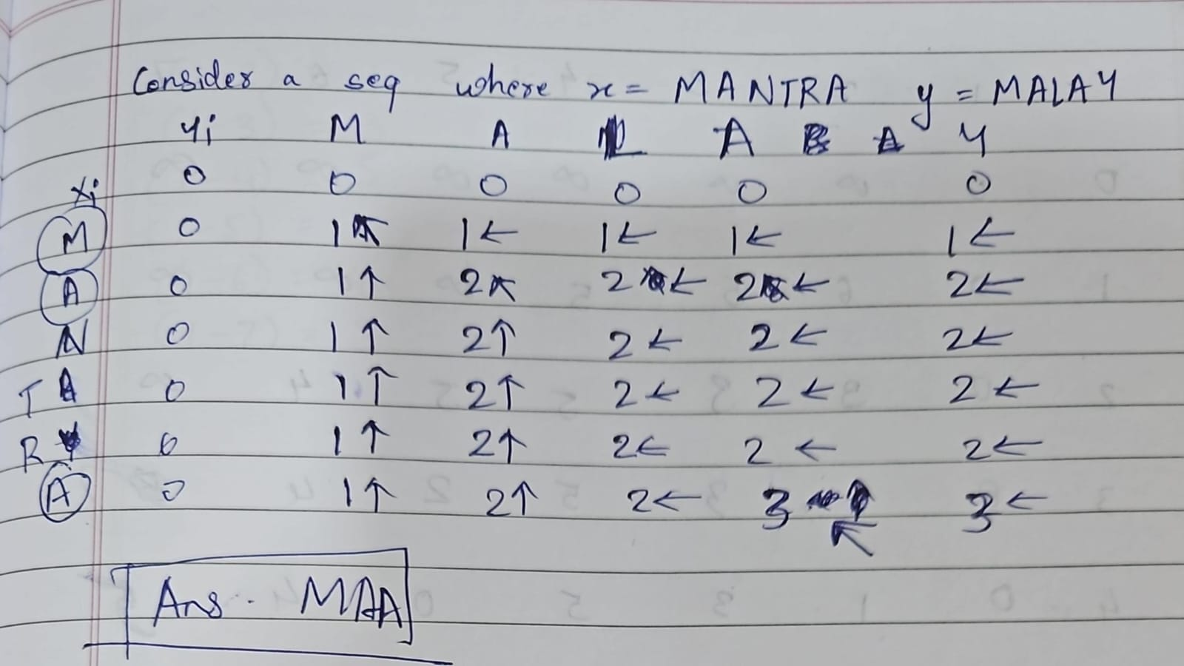
Analysis of LCS computation
Time complexity : O(n*m)
Where n and m are the lengths of the string
Space Complexity : O(n*m)

Code:
#include <bits/stdc++.h>
using namespace std;

#define int long long
#define endl "\n"

const int MOD = 1e9 + 7;
const int INF = LLONG_MAX >> 1;

void lcsAlgo(const char *S1, const char *S2, int m, int n) {
int LCS_table[m + 1][n + 1];

for (int i = 0; i <= m; i++) {
for (int j = 0; j <= n; j++) {
if (i == 0 || j == 0)
LCS_table[i][j] = 0;
else if (S1[i - 1] == S2[j - 1])
LCS_table[i][j] = LCS_table[i - 1][j - 1] + 1;
else
LCS_table[i][j] = max(LCS_table[i - 1][j], LCS_table[i][j - 1]);
}
}

int index = LCS_table[m][n];
char lcsStr[index + 1];
lcsStr[index] = '\0';

int i = m, j = n;
while(i > 0 && j > 0){
if (S1[i - 1] == S2[j - 1]){
lcsStr[index - 1] = S1[i - 1];
i--;
j--;
index--;
}
else if (LCS_table[i - 1][j] > LCS_table[i][j - 1]){
i--;
}
else{
j--;
}
}

cout<<"S1 : "<<S1<<"\nS2 : "<<S2<<"\nLCS: "<<lcsStr<<"\n";
}

signed main() {
cout<<"Enter the first string:\t";
string s1; cin >> s1;

cout<<"Enter the second string:\t";
string s2; cin >> s2;

int m = s1.length();
int n = s2.length();

lcsAlgo(s1.c_str(), s2.c_str(), m, n);
return 0;
}

Output:

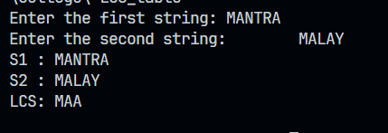
Algorithm:

X and Y be two given sequences
Initialize a table LCS of dimension X.length * Y.length
X.label = X
Y.label = Y
LCS[0][] = 0
LCS[][0] = 0
Start from LCS[1][1]
Compare X[i] and Y[j]
If X[i] = Y[j]
LCS[i][j] = 1 + LCS[i-1, j-1]
Point an arrow to LCS[i][j]
Else
LCS[i][j] = max(LCS[i-1][j], LCS[i][j-1])
Point an arrow to max(LCS[i-1][j], LCS[i][j-1])

CONCLUSION:

From this experiment we learnt about longest common subsequence using dynamic programming

